Policy RAG (PageIndex)
Technical Documentation
Retrieval-Augmented Generation for Legal & Insurance Documents

Version 1.0 | March 2026
Python 3.10 · FastAPI · OpenAI GPT-4o · pdfplumber · Vanilla JS

1. Project Overview
Policy RAG (PageIndex) is a Retrieval-Augmented Generation system built specifically for complex legal and insurance documents. Unlike standard RAG systems that split text into arbitrary chunks, Policy RAG preserves the full document hierarchy — Chapters, Sections, and Sub-sections — so the AI always retrieves information with complete structural context.

Traditional RAG pipelines fail on policy documents due to arbitrary chunking that breaks legal clause logic, loss of parent-child relationships between sections, and garbled text from multi-column PDF layouts. Policy RAG solves all three through structure-preserving ingestion, LLM-guided tree navigation, and recursive context expansion.

2. System Architecture
The system has two pipelines — Ingestion and Retrieval — connected through a shared JSON Policy Tree. The Backend API (FastAPI) orchestrates all components, with the Frontend providing the user interface.

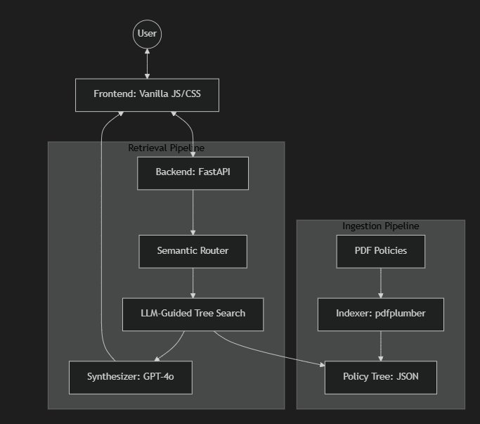

3. Core Modules

Module | File | Responsibility
Ingester / Indexer | src/indexer.py | Converts PDFs into structured JSON Policy Trees
Semantic Router | src/router.py | Classifies queries; selects target insurer IDs
Tree-Guided Retriever | src/retriever.py | LLM tree search with recursive child expansion
Synthesizer | src/synthesizer.py | Generates grounded answers with source citations
Backend API | src/main.py | FastAPI layer orchestrating all pipeline components

3.1 Ingester & Indexer
- Column-Aware Parsing: Pages are pre-cropped into left/right halves before text extraction, preventing content mixing from 2-column layouts.
- Hierarchy Detection: Regex patterns and font heuristics detect heading levels (H1–H3) and reconstruct the document's logical structure.
- JSON Tree Output: Each node in Docs/trees/ stores its title, hierarchical path, and up to 5,000 characters of text.

3.2 Semantic Router
- Query Classification: Determines if the question targets a Single Policy ("What is SBI's waiting period?") or requires a Comparison ("Compare SBI and HDFC exclusions").
- Insurer Selection: Extracts insurer_id(s) to narrow the search space and prevent cross-policy contamination.

3.3 Tree-Guided Retriever
- LLM Navigation: The JSON tree structure is fed to the LLM, which selects which branches to explore based on query intent — no vector similarity search.
- Recursive Expansion: When a relevant parent node is found, all descendant nodes are fetched automatically, guaranteeing complete retrieval of lists and sub-clauses.

3.4 Synthesizer
- Strict Grounding: GPT-4o is prompted to base every statement solely on retrieved context, preventing hallucination.
- Citation Mapping: Each answer segment is linked back to a specific policy tree node, enabling the UI to show exact source text on demand.

4. Data Flow & Technical Highlights
4.1 End-to-End Data Flow

Step | Stage | Description
1 | Ingestion | PDF placed in /Docs; indexer.py produces policy_tree.json in Docs/trees/.
2 | Query | User submits a question via the web UI; frontend sends it to FastAPI.
3 | Routing | Semantic Router classifies query type and identifies target insurer(s).
4 | Tree Search | LLM Retriever navigates the JSON tree and identifies relevant section paths.
5 | Context Build | Text from selected nodes and all children assembled into a context block.
6 | Synthesis | GPT-4o generates a structured, grounded answer with inline citations.
7 | Display | UI renders answer with clickable citations; users can download the source PDF.

4.2 Key Technical Solves

Challenge | Solution
2-Column PDF layouts mix adjacent column text during extraction. | Pages pre-cropped into halves via pdfplumber before extraction, maintaining reading order.
Long enumerated lists (e.g., disease exclusions) get truncated across chunks. | Node limit raised to 5,000 chars; recursive child expansion guarantees full list retrieval.
Researchers need to cross-reference answers with source documents efficiently. | Resizable sidebar with interactive document previews and one-click PDF download.

4.3 Technology Stack

Category | Technology | Usage
Backend | Python 3.10 | Core language for all pipeline components
API | FastAPI | RESTful async API layer
PDF Parsing | pdfplumber | Column-aware text and layout extraction
AI / LLM | OpenAI API (GPT-4o) | Tree navigation, synthesis, grounding
Frontend | Vanilla JavaScript | Lightweight chat and document review UI
Styling | CSS Grid / Flexbox | Responsive layout with resizable sidebar
Data | JSON | Policy Tree storage and node interchange

